|  |  |  |  |
| --- | --- | --- | --- |
| **Course Name:** | **Elements of Electrical and Electronics Engineering** | **Semester:** | **I** |
| **Date of Submission:** | **24/01/22** | **Batch No:** | **G3** |
| **Faculty Name:** | **Seema Talmale** | **Roll No:** | **16010421071** |
| **Faculty Sign & Date:** |  | **Grade/Marks:** | **/ 20** |

**Internal Assessment: 2**

**Case Study on Electricity Consumption and Billing of a Home.**

**1. What is Electrical Power and Energy? What are their Units?**

**Answer:**

1. Electric power is the rate, per unit time, at which electrical energy is transferred by an electric circuit Or Electric power is the rate at which work is done or energy is transformed into an electrical circuit.
2. The SI unit of power is the watt, one joule per second. Electrical energy is energy derived from [electric potential energy](https://en.wikipedia.org/wiki/Electric_potential_energy) or [kinetic energy.](https://en.wikipedia.org/wiki/Kinetic_energy) When used loosely, electrical energy refers to energy that has been converted from electric potential energy.
3. This energy is supplied by the combination of [electric current](https://en.wikipedia.org/wiki/Electric_current) and [electric potential](https://en.wikipedia.org/wiki/Electric_potential) that is delivered by an [electrical circuit](https://en.wikipedia.org/wiki/Electrical_circuit) .Once converted from potential energy, electrical energy can always be called another type of energy.
4. Electrical energy is usually sold by the [kilowatt hour.](https://en.wikipedia.org/wiki/Kilowatt_hour) Units of Electric Power are Watt (SI Unit), VA, kW, Joule per second, Horsepower(1HP=746 W)etc.
5. A body is said to have power of 1 watt if it does work at the rate of 1 joule in 1 s. Electrical energy is the energy derived from electric potential energy or kinetic energy of the charged particles. In general, it is referred to as the energy that has been converted from electric potential energy. We can define electrical energy as the energy generated by the movement of electrons from one point to another. The movement of charged particles along/through a medium (say wire) constitutes current or electricity.
6. The basic unit of electrical energy is the joule or watt-second. An electrical energy is said to be one joule when one ampere of current flows through the circuit for a second when the potential difference of one volt is applied across it. The commercial unit of electrical energy is the kilowatt-hour (kWh) which is also known as the Board of trade unit (B.O.T).

1 kwh = 1000 × 60 × 60 watt – second 1 kwh = 36 × 10^5 Ws or Joules

Generally, one kwh is called one unit.

**2**. **What is 1 unit of Electrical Energy?**

**Answer:** 1 unit of electrical energy is equal to 1 kWh. For example, if an electrical appliance of power 1000 watt is operated on mains for 1 hour, it will consume 1 unit of electricity. It is commercially known as ‘unit’. It is also called B.O.T. (Board of Trade Unit).

1kWh = 1000Wh.

1kWh = 1000 x 60 x 60 W second.

1kWh = 3600000 W second.

1kWh = 3.6 x 106J.

1kWh = 3.6 MJ.

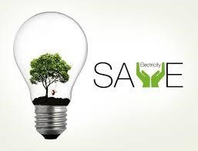

**3. Estimate the Electrical Consumption of your home for Two Months. (Units/Month). {November’21 and December’21 - following table is applicable as per actuals}**

**Answer:**

|  |  |  |  |  |  |  |
| --- | --- | --- | --- | --- | --- | --- |
| Sr.No. | Appliances | Power Rating (Watts/Appliance) {a} | Number of Appliances {b} | Utilization in Hours Per Day {c} | Energy in Wh/1000 (units)/Day {d = a*b*c/1000} | Energy Units/Month  {d*30} |
| 1 | Lights | 40  10 | 3 (tube light)  6 (bulbs) | 4  6 | 0.48  0.36 | 14.4  10.8 |
| 2 | Fans | 75 | 2 | 4 | 0.6 | 18 |
| 3 | Washing Machine | 2000 | 1 | 1 | 2 | 60 |
| 4 | Electric Geyser | 4500 | 1 | 0 | 0 | 0 |
| 5 | Water Purifier | 100 | 1 | 0.25 | 0.025 | 0.75 |
| 6 | Fridge | 240 | 1 | 19 | 4.56 | 136.8 |
| 7 | Microwave Oven | 650 | 1 | 0.25 | 0.1625 | 4.875 |
| 8 | Laptop | 75 | 1 | 12 | 1.5 | 45 |
| 9 | Air Conditioner | 1000 | 1 | 0 | 0 | 0 |
| 10 | Television | 60 | 2 | 0 | 0 | 0 |

Total Energy {November’21} (Units/Month) = 290.625

|  |  |  |  |  |  |  |
| --- | --- | --- | --- | --- | --- | --- |
| Sr.No. | Appliances | Power Rating (Watts/Appliance) {a} | Number of Appliances {b} | Utilization in Hours Per Day {c} | Energy in Wh/1000 (units)/Day {d = a*b*c/1000} | Energy Units/Month  {d*30} |
| 1 | Lights | 40  10 | 3 (tube light)  6 (bulbs) | 3 1 | 0.36  0.06 | 10.8  1.8 |
| 2 | Fans | 75 | 2 | 0.16 | 0.024 | 0.72 |
| 3 | Washing Machine | 2000 | 1 | 0.75 | 1.5 | 45 |
| 4 | Electric Geyser | 4500 | 1 | 0 | 0 | 0 |
| 5 | Water Purifier | 100 | 1 | 0.13 | 0.013 | 0.39 |
| 6 | Fridge | 240 | 1 | 16 | 3.84 | 115.2 |
| 7 | Microwave Oven | 650 | 1 | 0.15 | 0.0975 | 2.925 |
| 8 | Laptop | 75 | 1 | 3 | 0.225 | 6.75 |
| 9 | Air Conditioner | 1000 | 1 | 0 | 0 | 0 |
| 10 | Television | 60 | 2 | 0 | 0 | 0 |

Total Energy {December’21} (Units/Month) = 183.585

**Plot a bar graph showing appliances on X-axis and energy (units/month/appliance) on Y-axis. Draw the graph for both the months (can use Microsoft Excel to plot the graphs).**

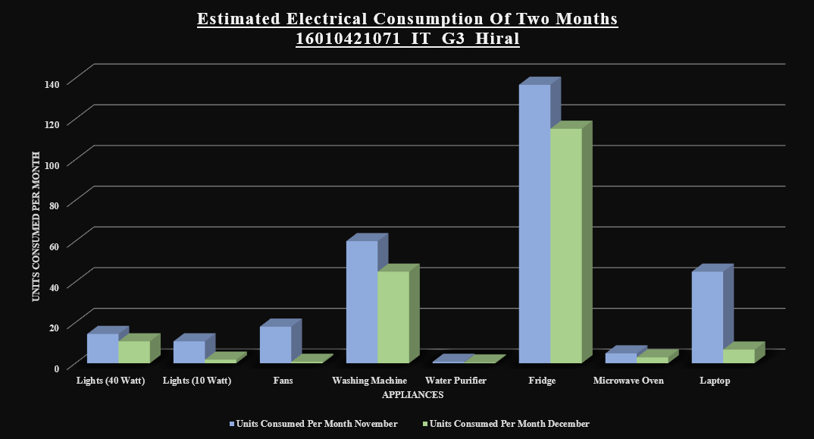

**4.** **Compare actual Electricity Units and Bill (Rupees) with your estimation. {Use Electricity Bill of recent month of your home, attach a copy of the same with the assignment}**

**Answer:**

**November’21**

|  |  |  |  |
| --- | --- | --- | --- |
| Energy Consumption | Energy (Units/Month) | Billing Rate (Rupee/Unit) | Total (Rupees) |
| Estimated | 290.625 | 200 x 7.34 + 90.625 x 7.34 + 150 | 2283.1875 + additional taxes = 2597.2475 |
| Actual | 291 | 200 x 7.34 + 91 x 7.34 + 150 | 2285.94 + additional taxes = 2600 |

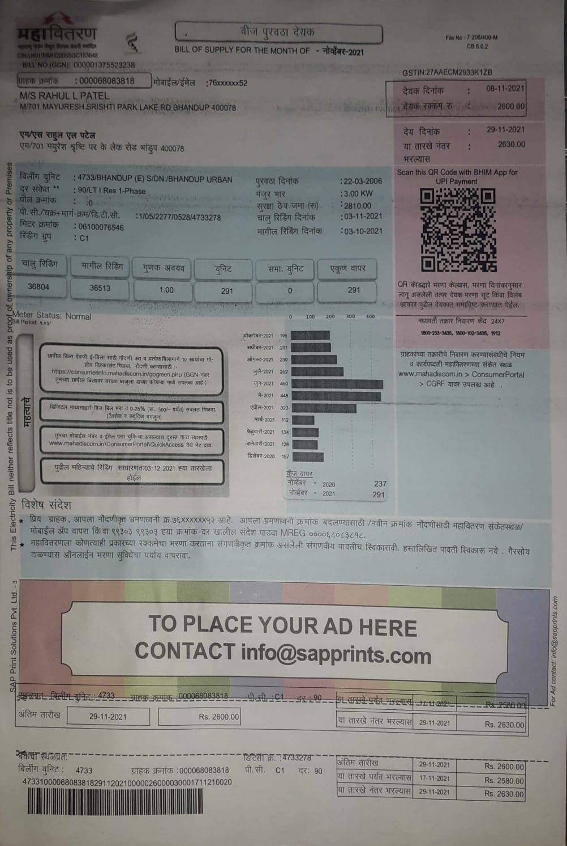

**December’21**

|  |  |  |  |
| --- | --- | --- | --- |
| Energy Consumption | Energy (Units/Month) | Billing Rate (Rupee/Unit) | Total (Rupees) |
| Estimated | 183.585 | 100 x 3.44 + 83.585 x 7.34 + 150 | 1107.5139 + additional taxes = 1503.4639 |
| Actual | 183 | 100 x 3.44 + 83 x 7.34 +150 | 1104.05 + additional taxes = 1500 |

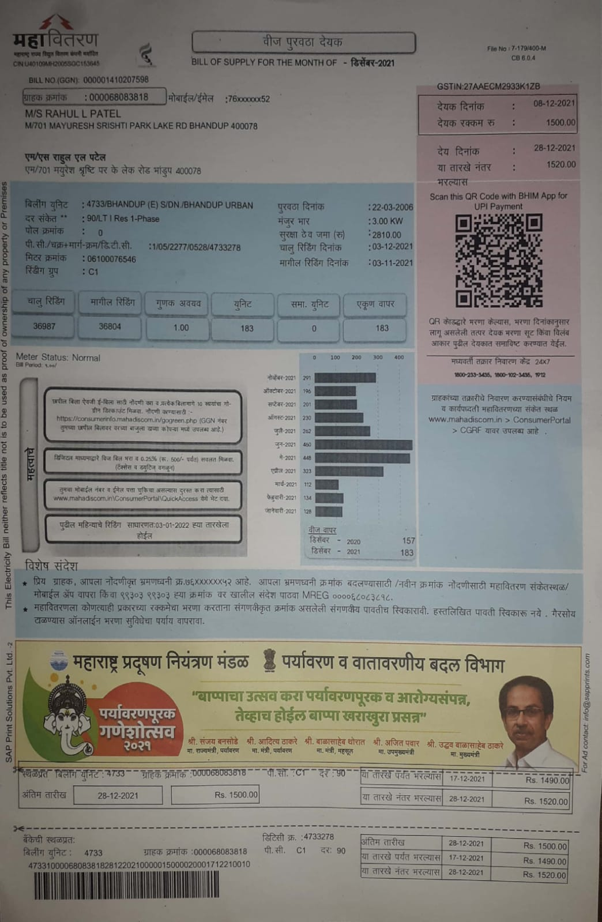

**5. How can you reduce Electrical Energy Consumption of your home? Alternative methods e.g., use of energy efficient lights, use of gas water heater instead of electric water heater etc.?**

**Answer:**

1. Shutdown your computer: Opting to shut down over using a screensaver does not affect your computer’s lifespan.
2. Choose the right light: LED’S use 75% less electricity than incandescent bulbs. They also have no mercury, and lasts almost 25times more than the traditional incandescent bulbs.
3. Eliminate vampire power: unplug idle electronic devices like televisions, microwaves, scanners, and printers. They use standby power, even when off. Some chargers continue to pull small amounts of energy even when charging is completed.
4. Use a power strip to reduce your plug load: flipping the switch on your power strip has the same effect as unplugging each socket from the wall, preventing phantom energy loss.
5. Turn off the lights and reduce the usage: turn the lights off when not in use and try reducing the hours for using the appliances.
6. Energy label appliances: use energy labelled appliances with low wattage in order to reduce the consumption.
7. Use devices: use gas geysers over electric one’s. Avoid using extra appliances. For example, using a kettle while having an oven. Buy appliances that have low carbon footprint and are rated above or equal to 3stars.
8. Using smart sensors that automatically switch off air conditioners, fans and lights when not needed.
9. Washing and drying clothes manually instead of using washing machines and dryers.

10) Using solar heaters instead of electric heaters.

**6. Estimation of Electrical Energy Consumption after alternate methods suggested in Q5).**

**Answer:**

Total Energy {November’21} (Units/Month) =

|  |  |  |  |  |  |  |
| --- | --- | --- | --- | --- | --- | --- |
| Sr.No. | Appliances | Power Rating (Watts/Appliance) {a} | Number of Appliances {b} | Utilization in Hours Per Day {c} | Energy in Wh/1000 (units)/Day {d = a*b*c/1000} | Energy Units/Month  {d*30} |
| 1 | Lights | 12  5 | 3 (tube light)  6 (bulbs) | 3  2 | 0.108  0.06 | 3.24  1.8 |
| 2 | Fans | 75 | 2 | 2 | 0.3 | 9 |
| 3 | Washing Machine | 2000 | 1 | 0.75 | 1.5 | 45 |
| 4 | Water Purifier | 100 | 1 | 0.25 | 0.025 | 0.75 |
| 5 | Fridge | 240 | 1 | 16 | 3.84 | 115.2 |
| 6 | Microwave Oven | 650 | 1 | 0.25 | 0.1625 | 4.875 |
| 7 | Laptop | 75 | 1 | 8 | 0.6 | 18 |

Total Energy {November’21} (Units/Month) = 197.8

|  |  |  |  |  |  |  |
| --- | --- | --- | --- | --- | --- | --- |
| Sr.No. | Appliances | Power Rating (Watts/Appliance) {a} | Number of Appliances {b} | Utilization in Hours Per Day {c} | Energy in Wh/1000 (units)/Day {d = a*b*c/1000} | Energy Units/Month  {d*30} |
| 1 | Lights | 12  5 | 3 (tube light)  6 (bulbs) | 3 0.85 | 0.108  0.0255 | 3.24  0.765 |
| 2 | Fans | 75 | 2 | 0.3 | 0.045 | 1.35 |
| 3 | Washing Machine | 2000 | 1 | 0.75 | 1.5 | 45 |
| 4 | Water Purifier | 100 | 1 | 0.12 | 0.012 | 0.36 |
| 5 | Fridge | 240 | 1 | 16 | 3.84 | 115.2 |
| 6 | Microwave Oven | 650 | 1 | 0.13 | 0.0845 | 2.535 |
| 7 | Laptop | 75 | 1 | 3 | 0.225 | 6.75 |

Total Energy {December’21} (Units/Month) = 175.21

**Plot a bar graph showing the comparison of consumption of the month with alternate methods suggested.**

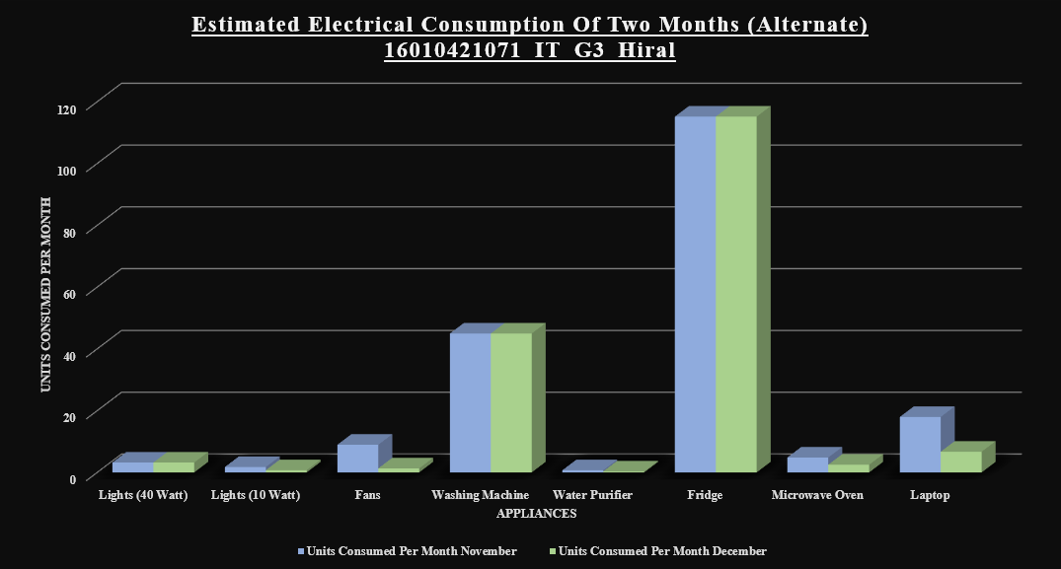

**7. Energy Saving Units/Month and Expenses in Rupees/Month (after implementation of alternative method suggested in Q5)**

**Answer:**

|  |  |  |  |  |  |  |
| --- | --- | --- | --- | --- | --- | --- |
| Month | Actual Units | Actual Bill | Units: Alternate Methods | Bill: Alternate Methods | Alternate Bill | Savings |
| November | 291 | 2600 | 197.8 | 100 x 3.44 + 97.8 x 7.34 + 150 | 1211.85 + additional charges = 1525.9 | 1074.1 |
| December | 183 | 1500 | 175.21 | 100 x 3.44 + 75.21 x 7.34 +150 | 1046.4 + additional charges = 1442.35 | 57.65 |

Monthly Savings if the above methods are implemented is: 565.875/- (approximate)

Yearly Saving = 565.875 * 12 = 6790.5/-

|  |
| --- |
| **Signature of faculty in-charge with Date:** |